WEEK ---12
TASK 1 REVERSE LINKED LIST﻿
Program ﻿
class Solution {﻿
public ListNode reverseList(ListNode head) {﻿
ListNode prev = null;﻿
ListNode current = head;﻿
while (current != null) {﻿
ListNode next = current.next;﻿
current.next = prev;﻿
prev = current;﻿
current = next;﻿
}﻿
return prev;﻿
}﻿
}﻿
Output
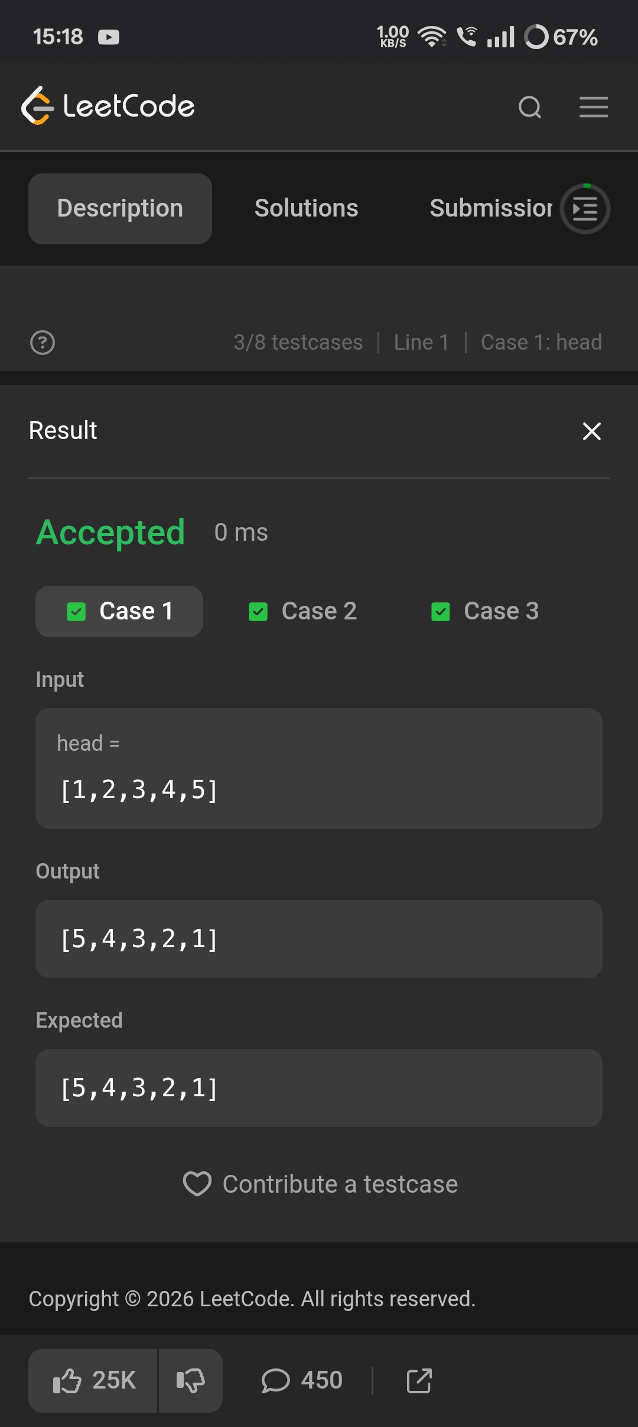
TASK 2 RELATIVE RANKS﻿
Program ﻿
import java.util.*;﻿
class Solution {﻿
public String[] findRelativeRanks(int[] score) {﻿
int n = score.length;﻿
String[] result = new String[n];﻿
Integer[] index = new Integer[n];﻿
// Store indexes﻿
for (int i = 0; i < n; i++) {﻿
index[i] = i;﻿
}﻿
// Sort indexes according to scores in descending order﻿
Arrays.sort(index, (a, b) -> score[b] - score[a]);﻿
// Assign ranks﻿
for (int i = 0; i < n; i++) {﻿
int originalIndex = index[i];﻿
if (i == 0) {﻿
result[originalIndex] = "Gold Medal";﻿
} else if (i == 1) {﻿
result[originalIndex] = "Silver Medal";﻿
} else if (i == 2) {﻿
result[originalIndex] = "Bronze Medal";﻿
} else {﻿
result[originalIndex] = String.valueOf(i + 1);﻿
}﻿
}﻿
return result;﻿
}﻿
}﻿
Output
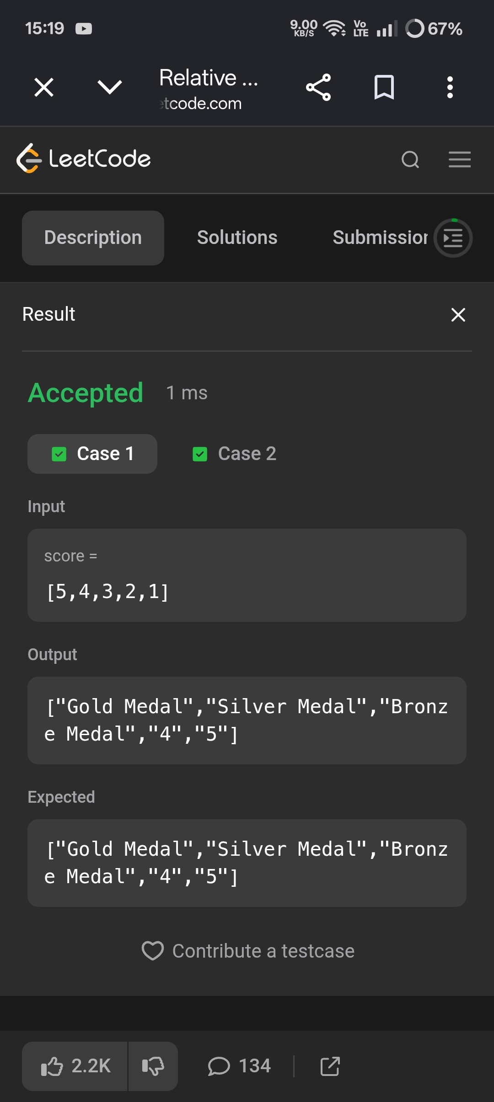
TASK 3 SORT ARRAY BY PARITY.﻿
Program ﻿
class Solution {﻿
public int[] sortArrayByParity(int[] nums) {﻿
int j = 0;﻿
for (int i = 0; i < nums.length; i++) {﻿
if (nums[i] % 2 == 0) {﻿
int temp = nums[i];﻿
nums[i] = nums[j];﻿
nums[j] = temp;﻿
j++;﻿
}﻿
}﻿
return nums;﻿
}﻿
}﻿
Output
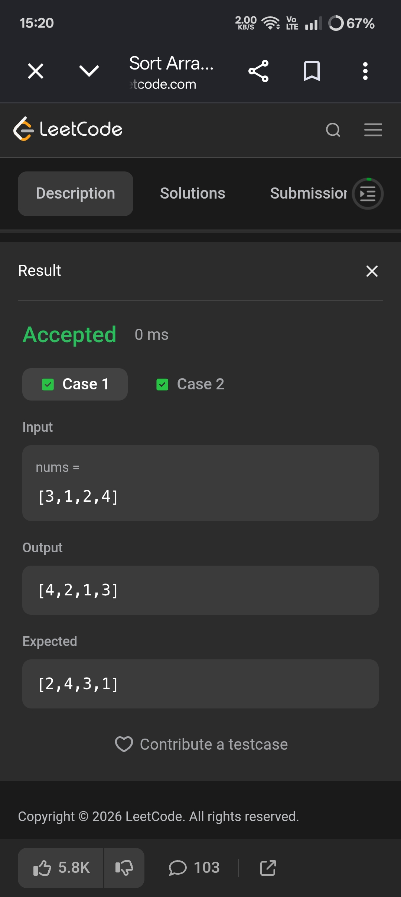
TASK 4 DISTRIBUTE CANDIES.﻿
Program ﻿
import java.util.*;﻿
class Solution {﻿
public int distributeCandies(int[] candyType) {﻿
HashSet<Integer> set = new HashSet<>();﻿
for (int candy : candyType) {﻿
set.add(candy);﻿
}﻿
return Math.min(set.size(), candyType.length / 2);﻿
}﻿
}﻿
Output
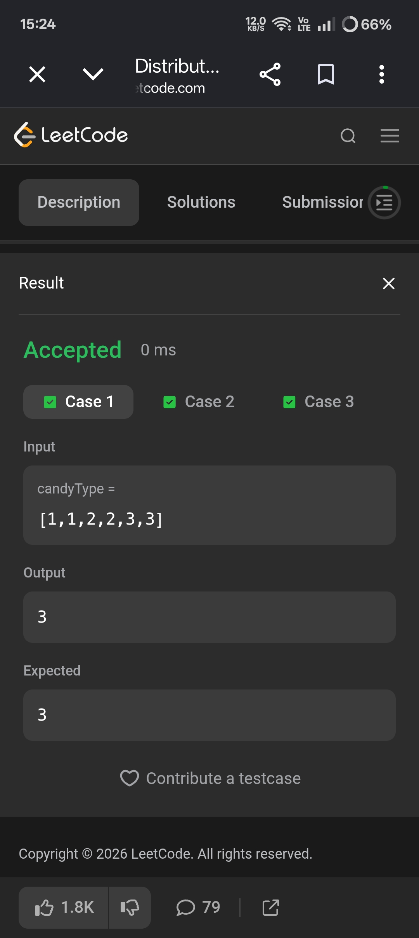
TASK 5 ISOMORPHIC STRINGS.﻿
Program ﻿
import java.util.*;﻿
class Solution {﻿
public boolean isIsomorphic(String s, String t) {﻿
HashMap<Character, Character> map1 = new HashMap<>();﻿
HashMap<Character, Character> map2 = new HashMap<>();﻿
for (int i = 0; i < s.length(); i++) {﻿
char a = s.charAt(i);﻿
char b = t.charAt(i);﻿
if (map1.containsKey(a) && map1.get(a) != b) {﻿
return false;﻿
}﻿
if (map2.containsKey(b) && map2.get(b) != a) {﻿
return false;﻿
}﻿
map1.put(a, b);﻿
map2.put(b, a);﻿
}﻿
return true;﻿
}﻿
}﻿
Output
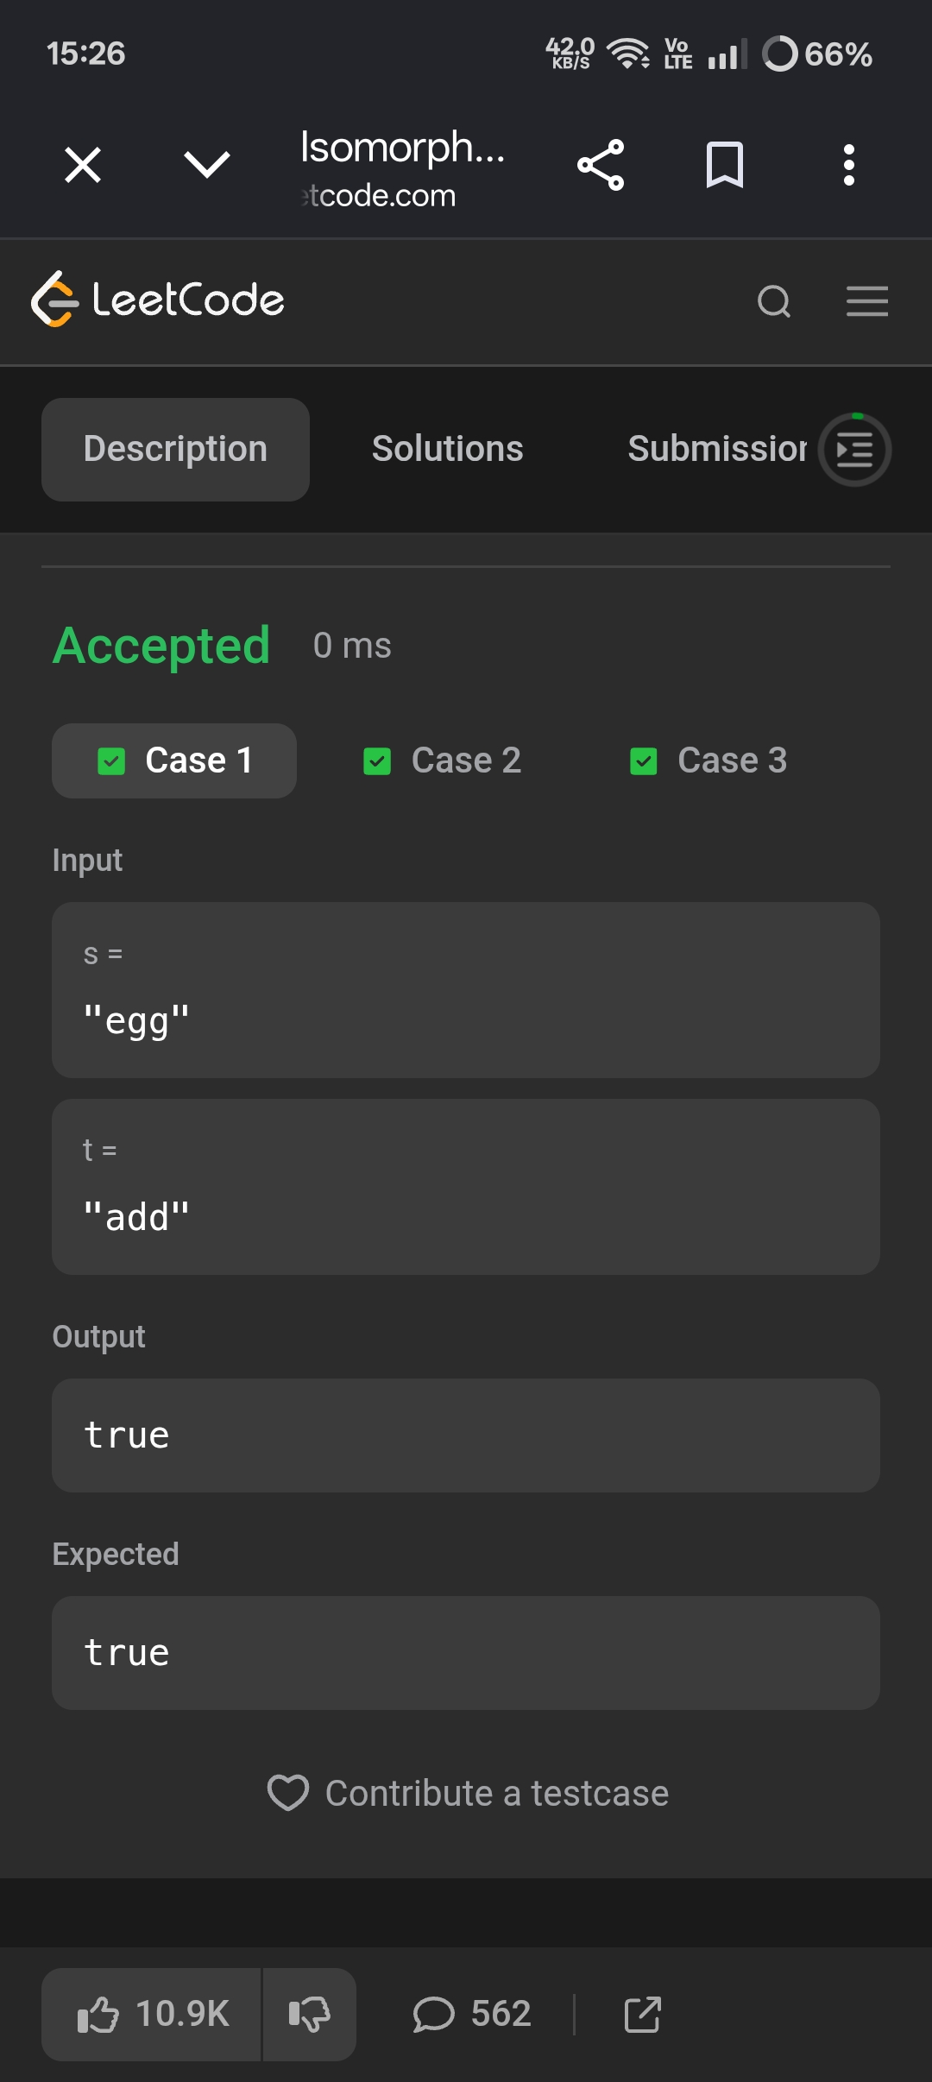
TASK 6 FIND ALL ANAGRAMS IN A STRING﻿
Program ﻿
import java.util.*;﻿
class Solution {﻿
public List<Integer> findAnagrams(String s, String p) {﻿
List<Integer> result = new ArrayList<>();﻿
if (s.length() < p.length()) {﻿
return result;﻿
}﻿
int[] count = new int[26];﻿
// Count characters of p﻿
for (char c : p.toCharArray()) {﻿
count[c - 'a']++;﻿
}﻿
int left = 0;﻿
for (int right = 0; right < s.length(); right++) {﻿
count[s.charAt(right) - 'a']--;﻿
// Window size becomes equal to p﻿
if (right - left + 1 == p.length()) {﻿
boolean anagram = true;﻿
for (int i = 0; i < 26; i++) {﻿
if (count[i] != 0) {﻿
anagram = false;﻿
break;﻿
}﻿
}﻿
if (anagram) {﻿
result.add(left);﻿
}﻿
count[s.charAt(left) - 'a']++;﻿
left++;﻿
}﻿
}﻿
return result;﻿
}﻿
}﻿
Output



